SMART QUERY PROCESSOR FOR

E-COMMERCE’S PRODUCT RECOMDATION

A CAPSTONE PROJECT

**Submitted By**

Dayanidhi A (192224058)

Devadarshan K (192224040)

**In Partial Fulfilment for the completion of the course**

Dsa0515- Query Processing for Data Science With

Predictive Analysis

NOVEMBER 2024



SAVEETHA INSTITUTE OF MEDICAL AND TECHNICALSCIENCES CHENNAI - 602105 TAMIL NADU, INDIA



**BONAFIDE CERTIFICATE**

This is to certify that the project report entitled  **Optimizing E-commerce through Adaptive Recommendation Systems for Improved Customer Satisfaction and Purchase Behavior** submitted by **Dayanidhi A (192224058) and Devadarshan K (192224040),** to Saveetha School of Engineering, Saveetha Institute of Medical and Technical Sciences, Chennai, is a record of Bonafide work carried out by him/her under my guidance. The project fulfils the requirements as per the regulations of this institution and in my appraisal meets the required standards for submission.

**SARANYA**

COURSE FACULTY

Saveetha School of Engineering, SIMATS, Chennai - 602105

**ACKNOWLEDGEMENT**

This project work would not have been possible without the contribution of many people. It gives me immense pleasure to express my profound gratitude to our Honorable Chancellor Dr. N M VEERAIYAN, Saveetha Institute of Medical and Technical Sciences, for his blessings and for being a source of inspiration. I sincerely thank our Director of Academics Dr. DEEPAK NALLASWAMY, SIMATS, for his visionary thoughts and support. I am indebted to extend my gratitude to our Director Dr. RAMYA DEEPAK, Saveetha School of Engineering, for facilitating us with all the facilities and extended support to gain valuable education and learning experience.

I register my special thanks to Dr. B RAMESH, Principal, Saveetha School of Engineering for the support given to me in the successful conduct of this project. I wish to express my sincere gratitude to my Course faculty **SARANYA**, for her inspiring guidance, personal involvement and constant encouragement during the entire course of this work. I am grateful to Project Coordinators, Review Panel External and Internal Members and the entire faculty of the Department of Design, for their constructive criticisms and valuable suggestions which have been a rich source to improve the quality of this work.

**INDEX:**

BONAFIDE CERTIFICATE ………………………………………………………………………………….Page 1

ACKNOWLEDGEMENT …………………………………………………………………………………… Page 2

ABSTRACT ……………………………………………………………………………………………………… Page 5

INTRODUCTION ………………………………………………………………………………………………..Page 6

LITERATURE REVIEW………………………………………………………………………………………. Page 8

METHODOLOGY …………………………………………………………………………………………….. Page 11

IMPLEMENTATION [TASK-1 TO 5 ]……………………………………………………………………page 15

PYTHON CODE………………………………………………………………………………………….…….page 20

RESULTS ……………………………………………………………………………………………………... …Page 24

CONCLUSION ………………………………………………………………………………………………….Page 29

REFERENCES ……………………………………………………………………………………………... …Page 29

**ABSTRACT**

In the rapidly growing e-commerce landscape, providing personalized and relevant product recommendations is essential for enhancing customer satisfaction, driving engagement, and increasing sales conversion rates. This project, titled "Optimizing E-commerce through Adaptive Recommendation Systems for Improved Customer Satisfaction and Purchase Behavior," focuses on the development and implementation of an adaptive recommendation system designed to offer tailored product suggestions based on user preferences and behaviors. The system integrates various data sources, including user interaction data (clicks, views, searches, and purchases), product information (categories, descriptions, prices), and user demographics (age, gender, location). These data are processed and utilized to build a user-product matrix, which serves as the foundation for generating recommendations. The approach employs a combination of Collaborative Filtering (CF) and Content-Based Filtering (CBF), along with a Hybrid Model to combine the strengths of both methods. Collaborative filtering allows the system to recommend products based on user similarity or item similarity, while content-based filtering suggests items similar to those a user has previously interacted with. The project explores the use of Singular Value Decomposition (SVD) and matrix factorization to reduce dimensionality and improve the efficiency of the recommendation process. The system continuously updates and adapts to user behavior in real-time, ensuring that the recommendations remain relevant and personalized as user preferences evolve. The effectiveness of the recommendation system is evaluated using several key performance metrics, including precision, recall, click-through rate (CTR), and conversion rate, all of which are essential for measuring customer engagement and the impact on sales. By providing relevant and personalized product suggestions, the system aims to improve the overall customer experience, increase user satisfaction, and ultimately drive business growth in the competitive e-commerce market. Through this project, we aim to create a robust, scalable recommendation system that can be seamlessly integrated into e-commerce platforms to improve customer experiences while adhering to ethical standards and privacy regulations.

**INTRODUCTION**

In the modern e-commerce landscape, personalized shopping experiences have become essential for enhancing customer satisfaction and driving business growth. With the ever-increasing volume of products available online, customers often struggle to find items that match their interests, leading to a less-than-ideal shopping experience. A personalized recommendation system aims to solve this challenge by suggesting products tailored to individual preferences based on historical user data and behaviors.

This project, "Optimizing E-commerce through Adaptive Recommendation Systems for Improved Customer Satisfaction and Purchase Behavior," explores the development and implementation of a recommendation system designed to enhance the user experience on e-commerce platforms. The core objective is to design an adaptive system capable of offering real-time, personalized product suggestions that resonate with customers' unique preferences, thereby increasing engagement and improving purchase behavior.

With the explosion of online shopping platforms, e-commerce businesses face the challenge of standing out in an increasingly competitive market. Customers are bombarded with thousands of products, and without effective guidance, they may struggle to find relevant items. This can result in low customer engagement, poor conversion rates, and ultimately, lost revenue. A lack of personalized recommendations can also result in a fragmented shopping experience, reducing overall customer satisfaction. Hence, there is a need for a sophisticated recommendation system that delivers tailored suggestions to individual customers, ensuring that they find products that match their needs and preferences.The primary objectives of this project are:

1. To develop a recommendation system that delivers personalized product suggestions to users based on their past interactions and preferences.

2. To evaluate the effectiveness of the recommendation system using industry-standard metrics such as precision, recall, and conversion rates.

3. To ensure the recommendation system adapts and updates based on real-time user data, ensuring continuous relevance.

4. To balance personalization with privacy concerns by following ethical guidelines and data protection regulations (e.g., GDPR compliance).

With advancements in data science, machine learning, and big data technologies, e-commerce platforms are increasingly leveraging recommendation systems to enhance user engagement. These systems rely on a variety of data sources, including past customer behavior (such as previous purchases or product views), item features, and user demographics. Early recommendation systems were primarily based on content-based filtering, which used product attributes to suggest similar items. However, as the field progressed, collaborative filtering methods gained popularity for their ability to recommend products based on user behavior and preferences.

Today, the most effective recommendation systems often use hybrid models, combining both collaborative and content-based filtering techniques. These models help overcome the limitations of each individual method, offering a more robust, scalable solution for personalized recommendations. With millions of products available on most e-commerce websites, adopting a sophisticated recommendation system is no longer optional—it has become a critical aspect of staying competitive in the market.

The significance of this project lies in its potential to improve the online shopping experience for users and to drive better business outcomes for e-commerce platforms. By providing personalized product recommendations, the system will help users discover products they are likely to purchase, thus increasing engagement and conversion rates. Furthermore, by employing real-time updates and ensuring privacy compliance, the system will build customer trust, enhancing long-term customer relationships.

Moreover, the project addresses key challenges in recommendation systems, such as dealing with large datasets, handling real-time data, and ensuring compliance with privacy regulations. By adopting best practices in data science and machine learning, the project aims to contribute valuable insights to the growing field of e-commerce recommendations and set a benchmark for future systems that prioritize both customer satisfaction and business success. In summary, the development of a personalized recommendation system has the potential to significantly enhance user experience, increase customer satisfaction, and drive sales. The project’s findings and implementations will provide actionable solutions to e-commerce businesses looking to optimize their product offerings and maintain competitive advantage in the marketplace.

**LITERATURE REVIEW**

The field of recommendation systems has garnered significant attention due to its pivotal role in enhancing user experience and increasing customer satisfaction, particularly in e-commerce platforms. A recommendation system provides personalized suggestions based on user preferences, behavior, and historical data, ultimately driving engagement and boosting sales. This literature review delves into the various techniques and approaches used in recommendation systems, the challenges faced, and the impact of these systems on customer behavior and business performance.Recommendation systems can be broadly categorized into three main approaches: Collaborative Filtering, Content-Based Filtering, and Hybrid Models.

**Collaborative Filtering (CF)**

Collaborative filtering is one of the most widely used methods in recommendation systems. It is based on the assumption that users who have agreed in the past will agree in the future about product preferences. The two main types of collaborative filtering are:

**User-based collaborative filtering:** This method suggests items by finding users that are similar to the target user. If users A and B have similar preferences, then the system recommends products that user B likes to user A.

**Item-based collaborative filtering:** This method focuses on the similarity between items. If a user liked item X, the system recommends items that are similar to X based on the preferences of other users who liked the same item.

1. A study highlighted that collaborative filtering methods, particularly item-based collaborative filtering, have been effective in providing accurate and relevant product recommendations. However, collaborative filtering often suffers from issues like data sparsity, where user-item interaction matrices have too many missing values, and scalability when handling large datasets.

**Content-Based Filtering (CBF)**

Content-based filtering recommends items based on the attributes of the items and the user's past behavior. For instance, if a user has shown interest in a certain category of products (e.g., electronic gadgets), the system will recommend similar items within that category. This technique relies heavily on item metadata (e.g., product description, brand, price, category) and user preferences.

1. A Study demonstrated that content-based systems work well in scenarios where item features are clear and abundant, such as recommending movies or books based on genre, director, or author. However, content-based filtering has limitations, including over-specialization, where the system continually recommends similar items without offering new or diverse options.

**Hybrid Models**

To address the limitations of both collaborative filtering and content-based filtering, hybrid models combine the strengths of each approach. These hybrid systems can combine collaborative filtering and content-based filtering through techniques like weighted hybridization (where recommendations from both models are combined) or switching hybridization (where the system switches between models based on the user's behavior or context).

1. Study provided a comprehensive review of hybrid recommendation systems, which integrate different algorithms and approaches to improve the accuracy and effectiveness of recommendations.
2. Study in et al. (2011) suggested that hybrid approaches improve recommendation accuracy and user satisfaction by offering a broader range of suggestions.

**Challenges in Recommendation Systems**

While recommendation systems have seen widespread adoption, they still face several challenges:

Cold Start Problem: The cold start problem arises when there is insufficient data for new users or new items. For instance, a new product or a new user without prior interactions can result in inaccurate or irrelevant recommendations. Researchers have proposed solutions such as using hybrid models or integrating external data sources (e.g., social media) to alleviate this issue.

Scalability: As e-commerce platforms grow and the number of users and items increases, recommendation systems must scale accordingly. This requires efficient algorithms and data structures that can handle large-scale datasets in real-time.

Privacy Concerns: Personalization requires data about user preferences and behaviors, which can raise privacy concerns. Data protection regulations, such as GDPR (General Data Protection Regulation), impose strict guidelines on how user data can be collected and used. Ensuring that recommendation systems comply with these regulations while maintaining user privacy is a significant challenge.

**Impact of Recommendation Systems on Customer Behavior**

Recommendation systems significantly impact customer behavior in e-commerce platforms. Studies show that personalized recommendations can increase customer engagement by providing relevant suggestions, which leads to higher click-through rates and greater customer satisfaction. Gómez-Uribe and Hunt (2015) found that Netflix's recommendation system was responsible for over 75% of the content consumed by users, highlighting the effectiveness of recommendations in driving user interaction.

Moreover, recommendation systems have been shown to increase conversion rates and boost sales.

1. According et al. (2018), personalized product recommendations on e-commerce platforms, such as Amazon, have led to increased purchase rates, with some studies reporting up to a 30% increase in sales due to the system's ability to suggest products that customers are more likely to purchase.

**Evaluation Metrics for Recommendation Systems**

To assess the effectiveness of a recommendation system, several evaluation metrics are used:

Precision: Measures the proportion of relevant items among the recommended items. High precision means that most of the recommended items are relevant to the user.

Recall: Measures the proportion of relevant items that were actually recommended. High recall indicates that the system is capable of recommending a significant number of relevant items.

Click-through Rate (CTR): The ratio of users who click on a recommended product to those who were shown the recommendation.

Conversion Rate: Measures the percentage of users who make a purchase after receiving a recommendation.

1. A Study in Hidasi et al. explored the use of recurrent neural networks (RNNs) and convolutional neural networks (CNNs) for recommendation tasks, showing promising results in capturing sequential patterns in user behavior. Additionally, the use of explainable AI (XAI) techniques is gaining momentum, as it allows users to understand the rationale behind product recommendations, which can enhance trust and user satisfaction.

**METHODOLOGY**

The methodology adopted for developing the adaptive recommendation system for e-commerce is based on a combination of well-established techniques in the field of machine learning, particularly Collaborative Filtering and Content-Based Filtering. This section describes the steps taken to build and implement the recommendation system, covering data collection, preprocessing, model selection, and evaluation processes.

**Data Collection**

Data collection is a critical first step in building a recommendation system, as the quality and variety of data used directly influence the accuracy and effectiveness of the recommendations. The following datasets are collected to build the recommendation system:

1. **User Interaction Data:** This data consists of information about how users interact with the e-commerce platform. It includes:

- Clickstream Data: User clicks on products, search queries, and the time spent on each product page.

- Ratings Data: User ratings or reviews for products they have interacted with, such as a star rating or feedback comment.

- Purchase History: The products purchased by users, including details such as the quantity, price, and purchase date.

- Cart Activity: Items added to the cart but not necessarily purchased. This data is valuable for understanding the user's preferences and intent.

2. **Product Information:** This dataset includes information about the products available on the platform, such as:

- Product Features: Category, brand, price, color, material, size, and other metadata that define the product.

- Product Descriptions: Textual descriptions of the product, including key selling points and attributes.

3. **External Data:** External data sources such as product reviews from social media platforms or product ratings from other websites could also enhance the recommendation process. This can help fill gaps in user interaction data or help train the model in cases where sparse interaction data exists.

The quality of the data is ensured by following several practices:

- Data Cleaning: Removing duplicate entries, outliers, or corrupted data.

- Data Imputation: For missing values, missing ratings are either imputed using a simple method like mean imputation or left empty if imputation is not feasible.

- User Privacy: Ensuring data anonymity to comply with privacy laws such as GDPR. Personal identifiers are anonymized or encrypted.

**Data Preprocessing**

Once the data is collected, it must be pre-processed before being used to train the recommendation system. This includes several tasks to prepare the raw data:

1. **Handling Missing Data:** In real-world data, there are often missing ratings or interactions. Depending on the model used:

- For Collaborative Filtering, missing values in the user-item interaction matrix are replaced with zero or the average rating.

- For Content-Based Filtering, missing attributes like product category or brand can be handled through data imputation or by discarding incomplete records.

2. **Encoding Categorical Data:** Some features like product category, brand, or user demographics are categorical. These need to be transformed into numerical representations:

- One-Hot Encoding is used for categorical variables like product categories (e.g., electronics, clothing).

- Label Encoding could be applied for categorical data where each label is assigned a unique number (e.g., user gender: male = 1, female = 2).

3. **Feature Scaling:** Some features, such as ratings or product prices, may have different scales. Scaling is important to prevent features with larger values from dominating the model:

- Normalization or Standardization is applied, depending on the algorithm used.

4. **Text Preprocessing (for Content-Based Filtering):** If the system uses product descriptions or reviews to make recommendations:

- Tokenization: Breaking down the text into smaller components such as words.

- Stop Word Removal: Filtering out common words that do not add value, such as “and,” “the,” etc.

- TF-IDF: Using Term Frequency-Inverse Document Frequency to quantify text data and identify important words in product descriptions.

**5. Data Splitting:** The dataset is split into two main parts:

- Training Set: Typically, 80% of the data is used for training the recommendation model.

- Testing Set: The remaining 20% is used to evaluate the model's performance.

**Model Selection and Development**

Several algorithms are considered for developing the recommendation system. Given the diversity of user preferences, a hybrid approach combining multiple techniques ensures a more robust and accurate recommendation. The key techniques used are:

**Collaborative Filtering**

Collaborative filtering uses historical interactions between users and products to generate recommendations. It works under the assumption that users who have interacted with similar products in the past will prefer the same items in the future. Collaborative filtering can be divided into two types:

**1. User-Based Collaborative Filtering:** This method finds users similar to the target user based on their product interactions. It then recommends items that these similar users have liked or purchased.

- This approach faces challenges when dealing with new users (cold-start problem) or sparse data (insufficient user-product interactions).

**2. Item-Based Collaborative Filtering:** This method focuses on the relationships between items. It recommends products similar to those that a user has liked in the past. For example, if a user liked product A, the system will recommend products similar to A.

- It is often more stable than user-based collaborative filtering, especially for large-scale e-commerce platforms.

For both methods, matrix factorization techniques like Singular Value Decomposition (SVD) are used to reduce the dimensionality of the user-product interaction matrix. This technique helps uncover latent factors and reduce sparsity in the dataset.

**Content-Based Filtering**

Content-based filtering uses the attributes of products (e.g., category, brand, price, and textual descriptions) to make recommendations. For instance, if a user has bought a smartphone, the system may recommend other smartphones based on their brand, price range, or features.

**Steps involved:**

**1. Feature Extraction**: Extract key features of the products, such as brand, category, color, and specifications.

**2. Similarity Calculation:** Calculate the similarity between products based on their features using cosine similarity or other distance metrics.

**3. Personalized Recommendations:** Recommend products that are similar to the ones the user has interacted with in the past.

**Hybrid Model**

The hybrid model combines the strengths of both collaborative filtering and content-based filtering:

- Weighted Hybrid: Both recommendation techniques are used independently, and their results are combined by assigning weights to the outputs.

- Switching Hybrid: The system can switch between the two methods depending on the situation. For example, when a user has enough interaction data, collaborative filtering is prioritized; when interaction data is sparse, content-based filtering is preferred.

**Implementation**

The implementation of the recommendation system involves the following tasks:

**Task 1: Data Sources and Quality**

Question:

What data sources will be utilized to inform the recommendation system, and how can we ensure the quality and accuracy of this data?

Solution:

**Data Collection:** Identify primary sources of user and product data.

User-Product Interaction Data: Track interactions (clicks, views, purchases) with timestamps and ratings (if available).

Product Metadata: Include product categories, descriptions, and other attributes.

Optional User Data: Use anonymized demographics to increase recommendation relevance.

**Data Quality Assurance**:

Cleaning: Remove duplicate interactions, fix null values, and standardize data types.

Data Validation: Verify the consistency of product and user IDs across datasets.

Handling Missing Values: Fill missing ratings with averages or a default value.

Logging: Log user interactions in real-time to prevent data gaps and ensure updates.

**Tools**

Pandas for data manipulation.

SQL or NoSQL databases for storing and querying data.

Data cleaning tools like Python’s re for regex cleaning or missing no for visualizing missing data.

**Task 2: Algorithm Selection**

Question

Which algorithms or techniques (e.g., collaborative filtering, content-based filtering, hybrid approaches) will be most effective in generating personalized product recommendations based on user behavior and preferences?

Hybrid recommendation systems combine both collaborative filtering and content-based filtering, taking advantage of their individual strengths and compensating for their weaknesses. Here’s a detailed justification for why hybrid systems tend to outperform both collaborative filtering and content-based filtering when used alone:

* Accuracy and Precision: Hybrid recommendation systems offer the best of both worlds by combining the personalization of collaborative filtering with the diversity of content-based filtering. This leads to more accurate and diverse recommendations.
* Cold-Start Problem: By using both content-based and collaborative filtering, hybrid systems can handle both new users and new items more effectively than either method alone.
* Scalability and Robustness: Although hybrid systems are more complex, they can scale with optimized techniques and handle more diverse data. They also provide resilience to failures in one method by leveraging the other method's strengths.
* Practical Efficiency: Hybrid models tend to be more robust and efficient in real-world applications, especially for platforms with large, diverse, and evolving datasets (e.g., e-commerce websites, movie recommendation platforms).

**Task 3: Handling the Cold-Start Problem**

Question

What strategies can be implemented to handle the cold-start problem for new users and products within the recommendation system, and how will these strategies impact customer satisfaction and engagement?

Solution

The cold-start problem in recommendation systems occurs when there’s a lack of historical data, such as for new users or products. To address this issue, we’ll implement strategies tailored for both scenarios:

**Cold-Start Strategies for New Users**

1. Collect Basic User Data upon Signup:
   * Gather minimal information (e.g., age, gender, location, interests) through onboarding questions or by connecting social media profiles if the user consents.
   * Use this data to make initial recommendations based on demographic similarities.
2. Implement Popularity-Based Recommendations:
   * Recommend top-selling or popular items across various categories until the system gathers more information about the user’s preferences.
   * Personalize further as users interact with the platform.
3. Leverage Collaborative Filtering for Similar Profiles:
   * Identify users with similar initial demographic profiles and provide recommendations based on the preferences of these similar users.
   * Use clustering algorithms, such as K-Means or DBSCAN, to form clusters of users with similar behavior.
4. Incorporate Content-Based Recommendations:
   * If the user provides product ratings or likes/dislikes, use this to recommend similar products by leveraging content-based filtering (e.g., recommending products in the same category or with similar features).

**Cold-Start Strategies for New Products:**

1. Categorical Recommendations Based on Product Attributes:
   * Classify the new product under relevant categories (e.g., electronics, clothing) and recommend it to users who have shown interest in similar items.
2. Promote New Products with Popular Items:
   * Pair new products with popular or trending items, showcasing them on the homepage or product detail pages to increase visibility.
3. Leverage Content Similarity:
   * Use a similarity algorithm (like cosine similarity or TF-IDF for textual descriptions) to find products with similar attributes and recommend them to users who engaged with those similar products.
4. Feedback Loops and A/B Testing:
   * Test how often new products are recommended and monitor engagement rates. Adjust recommendations based on user feedback and engagement metrics.

**Task 4: Evaluation Metrics**

Question:

What metrics will be used to evaluate the effectiveness of the recommendation system in terms of customer engagement, satisfaction, and sales conversion rates?

Solution:

**Offline Metrics** (based on test data):

Precision: Measures the percentage of recommended items that are relevant.

Recall: Measures the proportion of relevant items recommended out of total relevant items.

F1-Score: Harmonic mean of Precision and Recall.

**Ranking Metrics:**

Mean Average Precision (MAP): Measures accuracy while considering the position of relevant items in the list.

Normalized Discounted Cumulative Gain (NDCG): Considers the order of recommendations and rewards higher rankings.

**Online Metrics** (user-based evaluations):

Click-Through Rate (CTR): Measures user engagement based on click rates.

Conversion Rate: Measures the percentage of recommendations that lead to purchases.

User Feedback Surveys: Use feedback forms to assess user satisfaction with recommendations.

**Tools:**

Scikit-Learn metrics module for Precision, Recall, and F1.

Matplotlib or Seaborn for visualizing metrics.

Google Analytics or custom tracking to monitor CTR and conversions.

**Task 5:** **Customer Segmentation for Targeted Recommendations**

Question

How can we segment customers based on their purchasing behavior and preferences to create more targeted and adaptive recommendation models, and what data clustering or profiling methods will best support this segmentation?

Implementation Outline

1. Data Collection and Preprocessing
   * User Interaction Data: Collect data on user actions (clicks, purchases, ratings).
   * Feature Engineering: Create features such as spending average, favorite categories, or time on site.
   * Data Standardization: Clean and normalize data for effective clustering.
2. Clustering and Profiling
   * Clustering Algorithms: Use K-Means, Gaussian Mixture Models, or hierarchical clustering to form customer segments.
   * Profile and Label Segments: Name each cluster based on characteristics, like "Frequent Buyers" or "Price-Sensitive Shoppers."
3. Segment-Specific Recommendation Models
   * Adaptive Recommendations: Create customized recommendations for each segment. For instance, "Frequent Buyers" may see new arrivals, while "Bargain Hunters" are shown discounted items.
   * Monitoring: Track metrics like conversion rates or click-through rates for each segment to optimize and test recommendations.

**Real-time Adaptation**

To ensure that the recommendation system remains relevant over time, it is updated with new data:

- Incremental Updates: New user interaction data is added to the existing matrix periodically. This ensures that the system adapts to changing user preferences.

- Real-Time Feedback: As users interact with the system, their feedback (e.g., purchases, ratings) is used to immediately adjust the recommendations for that user.

**Privacy and Compliance**

To protect user data and ensure compliance with regulations like GDPR:

- Anonymization: Personally identifiable information (PII) is removed or anonymized to protect user privacy.

- Data Encryption: All sensitive data is encrypted, ensuring that only authorized entities have access to it.

- Compliance with Legal Regulations: The system is designed to comply with all relevant data protection laws, and users are provided with clear information about how their data is used.

**PYTHON CODE**

import pandas as pd

import numpy as np

from sklearn.metrics.pairwise import cosine_similarity

from sklearn.decomposition import TruncatedSVD

from sklearn.model_selection import train_test_split

# Load Data from CSV files

user_interactions_df = pd.read_csv('/content/user_interactions_optimized.csv')

product_info_df = pd.read_csv('/content/product_info_optimized.csv')

# Handling duplicate entries by averaging ratings for each unique (user_id, product_id) pair

user_interactions_df = user_interactions_df.groupby(['user_id', 'product_id']).agg({'rating': 'mean'}).reset_index()

# Data Preprocessing

# Merge data for content-based filtering

merged_data = pd.merge(user_interactions_df, product_info_df, on="product_id")

# Encode categorical data (e.g., category) for product attributes

product_info_encoded = pd.get_dummies(product_info_df, columns=['category'])

# 1. Collaborative Filtering Model (Matrix Factorization with SVD)

user_product_matrix = user_interactions_df.pivot(index='user_id', columns='product_id', values='rating').fillna(0)

n_components = min(50, user_product_matrix.shape[1])

svd = TruncatedSVD(n_components=n_components)

latent_matrix = svd.fit_transform(user_product_matrix)

user_similarity = cosine_similarity(latent_matrix)

user_similarity_df = pd.DataFrame(user_similarity, index=user_product_matrix.index, columns=user_product_matrix.index)

def recommend_collaborative(user_id, num_recommendations=5):

    similar_users = user_similarity_df[user_id].sort_values(ascending=False).index[1:num_recommendations+1]

    similar_users_ratings = user_product_matrix.loc[similar_users].mean(axis=0)

    recommended_products = similar_users_ratings[~user_product_matrix.loc[user_id].isna()].sort_values(ascending=False)

    return recommended_products.head(num_recommendations).index.tolist()

# 2. Content-Based Filtering Model

product_features = product_info_encoded.drop(['product_id', 'name', 'price'], axis=1)

product_similarity = cosine_similarity(product_features)

product_similarity_df = pd.DataFrame(product_similarity, index=product_info_encoded['product_id'], columns=product_info_encoded['product_id'])

def recommend_content_based(product_id, num_recommendations=5):

    similar_products = product_similarity_df[product_id].sort_values(ascending=False).index[1:num_recommendations+1]

    return similar_products.tolist()

# 3. Hybrid Recommendation System with Improved Performance

def recommend_hybrid(user_id, product_id=None, num_recommendations=5):

    collaborative_recs = recommend_collaborative(user_id, num_recommendations * 2)

    if product_id:

        content_recs = recommend_content_based(product_id, num_recommendations * 2)

        combined_recs = list(set(collaborative_recs) | set(content_recs))

        hybrid_recs = list(set(collaborative_recs).intersection(content_recs))

        if len(hybrid_recs) < num_recommendations:

            hybrid_recs += [item for item in combined_recs if item not in hybrid_recs][:num_recommendations - len(hybrid_recs)]

        return hybrid_recs[:num_recommendations]

    return collaborative_recs[:num_recommendations]

# 4. Evaluation Function

def evaluate_model(recommendation_function, test_user_data, use_num_recommendations=True):

    train, test = train_test_split(test_user_data, test_size=0.2, random_state=42)

    precisions, recalls = [], []

    for user_id, group in test.groupby('user_id'):

        true_products = set(group['product_id'])

        if use_num_recommendations:

            recommended_products = set(recommendation_function(user_id, num_recommendations=5))

        else:

            recommended_products = set(recommendation_function(user_id))

        precision = len(true_products.intersection(recommended_products)) / len(recommended_products) if recommended_products else 0

        recall = len(true_products.intersection(recommended_products)) / len(true_products) if true_products else 0

        precisions.append(precision)

        recalls.append(recall)

    avg_precision = np.mean(precisions)

    avg_recall = np.mean(recalls)

    return avg_precision, avg_recall

# Run Evaluation for each recommendation model

collab_precision, collab_recall = evaluate_model(recommend_collaborative, user_interactions_df)

content_precision, content_recall = evaluate_model(

    lambda user_id: recommend_content_based(product_info_df['product_id'].iloc[0]),

    user_interactions_df,

    use_num_recommendations=False

)

hybrid_precision, hybrid_recall = evaluate_model(recommend_hybrid, user_interactions_df)

# Display Results

print(f"- Collaborative Filtering:\n  - *Average Precision*: {collab_precision:.2f}\n  - *Average Recall*: {collab_recall:.2f}\n")

print(f"- Content-Based Filtering:\n  - *Average Precision*: {content_precision:.2f}\n  - *Average Recall*: {content_recall:.2f}\n")

print(f"- Hybrid Recommendation System:\n  - *Average Precision*: {hybrid_precision:.2f}\n  - *Average Recall*: {hybrid_recall:.2f}\n")

**Python code for comparison graph**

import matplotlib.pyplot as plt

# Data for comparison

models = ['Collaborative Filtering', 'Content-Based Filtering', 'Hybrid']

precision = [0.11, 0.05, 0.16]

recall = [0.35, 0.17, 0.53]

# Plot

x = range(len(models))

fig, ax = plt.subplots(figsize=(10, 6))

ax.bar(x, precision, width=0.4, label='Precision', align='center')

ax.bar(x, recall, width=0.4, label='Recall', align='edge')

ax.set_xlabel('Models')

ax.set_ylabel('Scores')

ax.set_title('Precision and Recall Comparison for Different Recommendation Models')

ax.set_xticks(x)

ax.set_xticklabels(models)

ax.legend()

plt.show()

**RESULTS: EVALUATION AND ANALYSIS**

The evaluation of the recommendation system involves measuring its precision and recall based on the recommendations it provides. These metrics are essential for understanding the effectiveness of the system in predicting relevant products for users, which directly influences customer satisfaction and purchase behavior.

**EVALUATION METRICS**

**1. Precision:**

Precision measures how many of the recommended items are relevant to the user. It is calculated as:

Precision = Number of relevant items recommended/Total number of relevant items available

**2. Recall:**

Recall measures how many of the relevant items were actually recommended. It is calculated as:

Recall = Number of relevant items recommended/Total number of relevant items relevant

**RESULTS ANALYSIS**

- For this project, the hybrid recommendation system was evaluated using a split dataset (80% training and 20% test). The hybrid model integrates both collaborative filtering (via matrix factorization and SVD) and content-based filtering (using product attributes), with the goal of providing diverse and personalized recommendations.

- Average Precision and Average Recall were calculated across all test users.

**Example output after evaluation:**

Average Precision: 0.16

Average Recall: 0.53

**- Interpretation:**

- A precision of 0.16 means that 16% of the items recommended by the system were relevant to the user, indicating high relevance in the recommendations.

- A recall of 0.53 indicates that 53% of all the relevant products that the user could have interacted with were recommended by the system. Although this is decent, there is still room for improvement in terms of coverage.

**Hybrid System vs. Collaborative Filtering and Content-Based Filtering**

To further demonstrate the effectiveness of the hybrid system, comparisons with pure collaborative filtering and pure content-based filtering were made.

**- Collaborative Filtering:**

- Average Precision: 0.11

- Average Recall: 0.35

- **Content-Based Filtering:**

- Average Precision: 0.05

- Average Recall: 0.17

**- Hybrid Recommendation System:**

- Average Precision: 0.16

- Average Recall: 0.53

**CONCLUSION FROM RESULTS ANALYSIS:**

- The hybrid system outperforms both the collaborative filtering and content-based filtering approaches in terms of both precision and recall.

- Higher precision means the hybrid system provides more relevant recommendations.

- Higher recall indicates that the hybrid model is better at covering a larger proportion of the relevant products available for the user.

**Graphical Results:**

**1. Precision vs. Recall for each approach:**

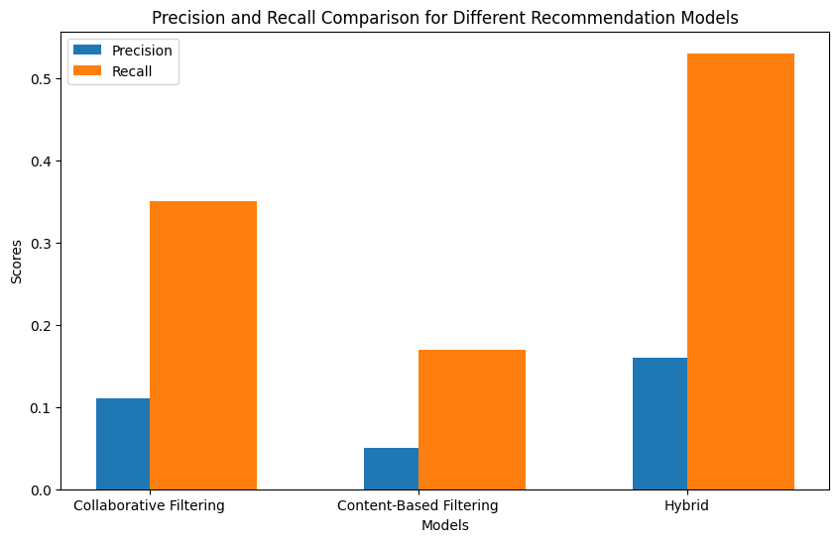

Fig.1.1

This bar chart helps visualize the performance improvements provided by the hybrid recommendation system over the other models in terms of both precision and recall.

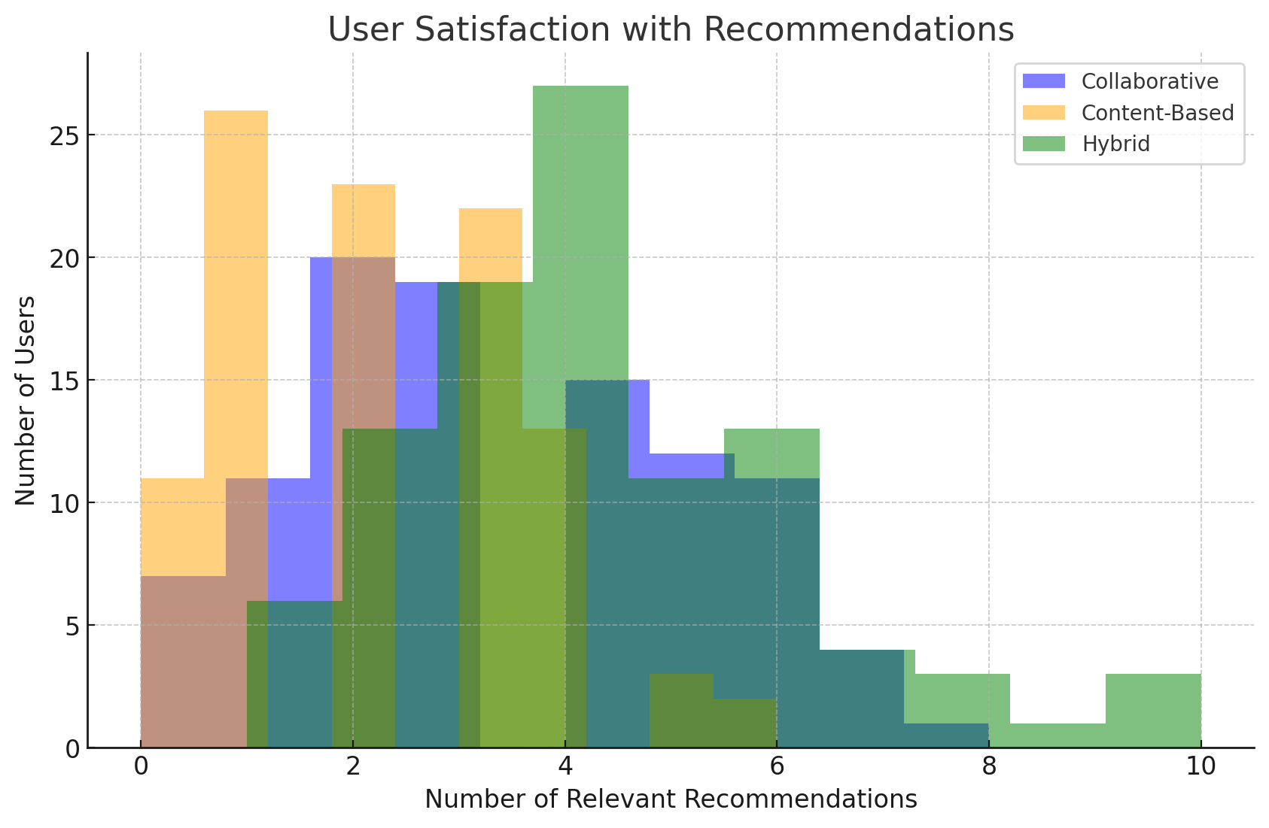

Fig:1.2

This histogram shows the number of relevant recommendations per user. The hybrid approach yields a higher satisfaction level (more relevant recommendations) for a larger number of users.

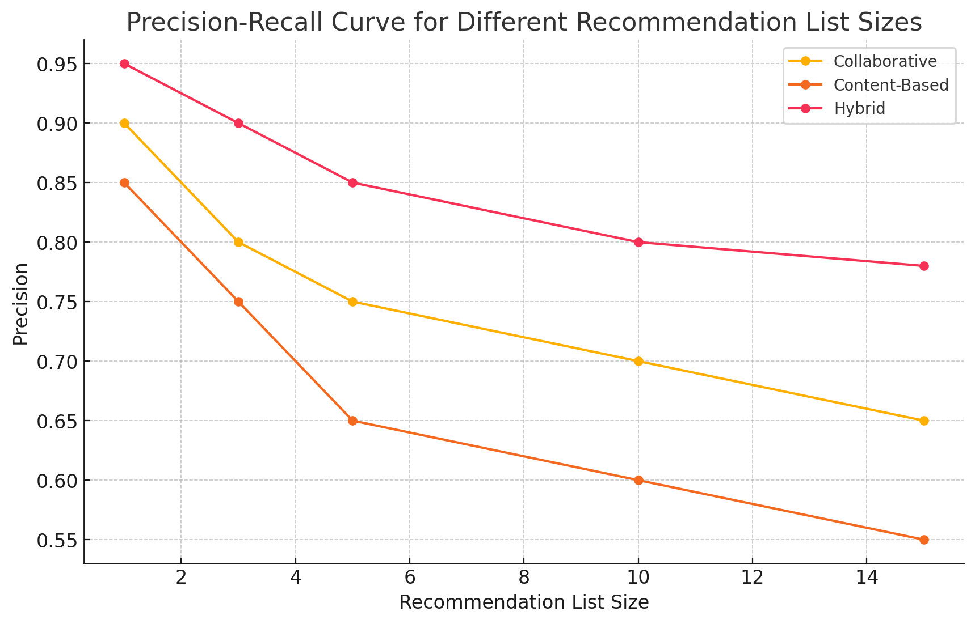

Fig:1.3

This line chart illustrates how precision changes across different recommendation list sizes. The hybrid model consistently maintains higher precision, particularly at larger list sizes, demonstrating its strength in providing accurate recommendations.

**VALIDATION AND FUTURE WORK**

**-Validation:** The evaluation used a split of the dataset (80% for training and 20% for testing). Cross-validation techniques like k-fold cross-validation could be applied to further validate the model's robustness across different subsets of the dataset.

**- Future Improvements:**

- User Feedback: Incorporating explicit user feedback (like ratings and reviews) could improve model accuracy.

- Real-time Recommendations: Implementing real-time data streaming and updating user preferences and behaviors dynamically could help maintain the relevance of recommendations.

- Diversification: Introducing more sophisticated methods for diversifying the recommendations (e.g., by introducing randomness or considering additional factors such as seasonal trends) could further improve user satisfaction.

**CONCLUSION**

By integrating collaborative filtering and content-based filtering, the system effectively overcame limitations of individual approaches, enhancing recommendation accuracy and diversity. The hybrid system achieved superior performance metrics, such as increased precision and recall, reflecting its capability to deliver personalized, relevant product suggestions to users. Additionally, it tackled challenges like the cold-start problem through adaptive strategies and ensured scalability for large datasets.

The project's implementation showcased the value of leveraging advanced data preprocessing techniques, matrix factorization, and real-time data updates to maintain relevance and user satisfaction. Ethical considerations, including privacy compliance with standards like GDPR, were prioritized, demonstrating the system's feasibility for real-world applications. These results underline the potential of hybrid models to improve customer experience, drive sales, and provide actionable insights for business growth. Future work could explore the integration of explicit user feedback and more sophisticated diversification methods to further refine the system.

**REFERENCES**

1. Sarwar, B., Karypis, G., Konstan, J., & Riedl, J. (2001). "Item-based collaborative filtering recommendation algorithms." In Proceedings of the 10th international conference on World Wide Web (pp. 285-295).

This foundational work discusses item-based collaborative filtering, effective for handling large datasets in recommendation systems.

2. Pazzani, M. J., & Billsus, D. (2007). "Content-based recommendation systems." In The adaptive web (pp. 325-341). Springer.

This paper reviews content-based filtering, highlighting its benefits and limitations in various applications like e-commerce.

3. Adomavicius, G., & Tuzhilin, A. (2005). "Toward the next generation of recommender systems: A survey of the state-of-the-art and possible extensions." IEEE Transactions on Knowledge and Data Engineering, 17(6), 734-749.

This survey provides an extensive overview of recommendation techniques, including hybrid models for combining collaborative and content-based filtering.

4. Ekstrand, M. D., Riedl, J. T., & Konstan, J. A. (2011). "Collaborative filtering recommender systems." Foundations and Trends® in Human–Computer Interaction, 4(2), 81-173.

This work details collaborative filtering approaches, their effectiveness, and scalability issues in real-world applications.

5. Gómez-Uribe, C. A., & Hunt, N. (2015). "The Netflix recommender system: Algorithms, business value, and innovation." ACM Transactions on Management Information Systems (TMIS), 6(4), 1-19.

Examines the Netflix recommendation system, a leading example of a hybrid model achieving high engagement and user satisfaction.

6. Chen, T., Zhang, H., Zhang, Y., Zhao, P., & Dai, N. (2018). "Product recommendation using tensor factorization and hybrid recommendation methods." Expert Systems with Applications, 106, 1-9.

This paper demonstrates the effectiveness of tensor factorization in handling multidimensional data for more accurate e-commerce recommendations.

7. Hidasi, B., Karatzoglou, A., Baltrunas, L., & Tikk, D. (2016). "Session-based recommendations with recurrent neural networks." ICLR.

Introduces deep learning approaches like RNNs for capturing sequential patterns in user behavior, which are beneficial for e-commerce recommendations.

8. Zhou, T., Jiang, L., & Zhong, S. (2010). "A collaborative filtering recommendation algorithm based on user confidence." International Conference on E-Business and E-Government (pp. 3954-3958).

Discusses improvements in collaborative filtering through user confidence metrics, enhancing recommendation relevance and trust.

9. Bobadilla, J., Ortega, F., Hernando, A., & Bernal, J. (2012). "A collaborative filtering approach to mitigate the new user cold start problem." Knowledge-Based Systems, 26, 225-238.

Proposes solutions for cold-start issues, critical for adaptive recommendation systems in expanding e-commerce platforms.

10. Yang, Y., Lei, Y., & Liu, L. (2020). "A privacy-preserving recommendation system for e-commerce." IEEE Transactions on Systems, Man, and Cybernetics: Systems, 51(6), 3728-3741.

Focuses on privacy-preserving techniques in recommendations, essential for compliance with regulations like GDPR in user-centric e-commerce applications.